
Lab Final Report
 |  | Only for course Teacher
 |  | Needs  Improvement | Developing | Sufficient | Above  Average | Total  Mark
Allocate mark & Percentage |  | 25% | 50% | 75% | 100% | 25
Understanding/Analysis | 7
Implementation | 8
Report Writing | 10
 |  | Total obtained mark
Comments
Semester: Spring 2025
Submission Date: 27/ 08 /2025
Course Code: SE 231 Course Name: System Analysis and Design Capstone Project
Course Teacher Name: Tahmina Meem
Designation: Lecturer, Department of Software Engineering
Group Member Details:
Student ID | Student Name
232-35-522 | Md.Minhazul Islam Bhuiyan
232-35-593 | Md. Nadimul Islam Nadim
232-35-503 | Sathi Begum
232-35-496 | Liza Akter
Section: K-1 (41)

Table of Contents
Introduction ....................................................................................................................................... 6
Objective ................................................................................................................................................ 6
Key Features ........................................................................................................................................... 6
Scenario writing: ................................................................................................................................ .8
Scenario 1: User Registration and Authentication .................................................................................. 8
Scenario 2: Role Base Access Control.......................................................................................................8
Scenario 3: Realtime Goods Tracking ..................................................................................................... 8
Scenario 4: Digital Documentation and Audit trail’s…………………………………………………………………………. 8
Scenario 5: Regulatory Compliance Monitoring .................................................................................... 8
Scenario 6: Supplier and vendor Compliance Scoring............................................................................. 9
Scenario 7:Incident and Non Compliance Reporting……………………………………………………………………………9
Scenario 8: automated Notification and escalation’s ............................................................................ 9
Scenario 9: AI-Based Predictive Analytics .............................................................................................. 9
Scenario 10: Interactive Dashboard and Analytics .................................................................................9
Scenario 11: Document Validation and (OCR)........................................................................................ 9
Scenario 12: Quality Inspection Workflow............................................................................................ 10
Scenario 13: QR Code/Barcode Generation.......................................................................................... 10
Scenario 14: Compliance Reporting and Export Tool’s ........................................................................ 10
Scenario 15: Feedback & Rating System for Partner’s........................................................................ 10
Scenario 16: Admin Control and Configuration panel ........................................................................ 10
Stakeholder ..................................................................................................................................... 10
User Profile ...................................................................................................................................... 11
User Profile-01: System Administrator ................................................................................................11
User Profile-02: General User’s ........................................................................................................... 12
User Profile-03:supplier........................................................................................................................ 12
User Profile-04:Compliance Manager..................................................................................................13
Scope .............................................................................................................................................. 14
- User Registration and Login ........................................................................................................... 14
- Role Based Access Control .............................................................................................................. 14
- Real Time Good tracking..................................................................................................................... 14
- Digital Documentation and Audit Trails ............................................................................................. 14
- Regulatory Compliance Monitoring............................................................................................. ….14
- Supplier & Vendor compliance scoring ......................................................................................... …14
- Incident & non- Compliance Reporting............................................................................................ 14
- Automated Notification & Escalations ............................................................................................ 15
- AI-Based predictive Analytics........................................................................................................... 15
- Interactive Dashboard & Analytics .................................................................................................. 15
- Document Validation &OCR ............................................................................................................ 15
- Quality Inspection Workflow ........................................................................................................... 15
- QR/Barcode Generation & Scanning ............................................................................................... 15
- Compliance Reporting &Export Tools .............................................................................................. 15
- Feedback & Rating System For Partners .......................................................................................... 15
- Admin Panel for Moderation & control ............................................................................................ 16
Feasibility Study .................................................................................................................................. 16
- Technical Feasibility ............................................................................................................................ 16
- Operational Feasibility ........................................................................................................................ 16
- Economic Feasibility ............................................................................................................................ 17
- Scheduling Feasibility .......................................................................................................................... 17
Project Block Diagram .......................................................................................................................... 18
Block Diagram – system Administrator:…………………………………………………………………….……………………….. 18
Block Diagram –(Compliance Manager, General User, Developer): ……………………………………………………..19
Block Diagram - Supplier: ........................................................................................................................ 20
Software Requirement Specification (SRS) ............................................................................................ 21
Use Case Diagram ................................................................................................................................. 23
User Case Description............................................................................................................................ 26
Case Description-01: Add/Edit/Delete User .............................................................................................. 26
Case Description-02: Assign User Role ...................................................................................................... 26
Case Description-03: Set Compliance Rules & Checklist…………………………………………..……………………………..27
Case Description-04: manage Notification Settings .................................................................................. 27
Case Description-05: Monitor System Activity ........................................................................................... 27
Case Description-06: Review uploaded Document .................................................................................... 28 Case Description-07: Approve or Reject Compliance File ……………………………………………………………………….28
Case Description-08: Generate Compliance Report ........................................................................................ 29
Case Description-09: View Supplier Compliance Dashboard…………………………………………………………………………29
Case Description-10: Register and Manage Profile ......................................................................................... 29
Case Description-11: Upload Certificate and Audit Report …………………………………………………………..………………30
Case Description-12: Update Company Information ....................................................................................... 30
Case Description-13: View Checklist ................................................................................................................ 30
Case Description-14: Receive Expiry Notification ............................................................................................ 31
Case Description-15: verify Document Format ................................................................................................ 31
Case Description-16:check System for Software Compliance ……………………………………………………………………….31
Case Description-17: Flag Invalid upload......................................................................................................... 32
Case Description-18: View Compliance status .................................................................................................32
Case Description-19: Search Supplier ................................................................................................ ……………33
System Design ............................................................................................................................................. 34
Data Flow Diagram ...................................................................................................................................... 34
Data Flow Diagram Level 0: ............................................................................................................................. 34
Data Flow Diagram Level 1: ............................................................................................................................. 35
Data Flow Diagram Level 2: ............................................................................................................................. 36
Activity Diagram ............................................................................................................................... 37
Activity Diagram-1:……………………………………………………………………………………………………………………………….37
Activity Diagram-2:……………………………………………………………………………………………………………………………….38
Activity Diagram-3:……………………………………………………………………………………………………………………………….39
Activity Diagram-4:……………………………………………………………………………………………………………………………….40
Activity Diagram-5:……………………………………………………………………………………………………………………………….41
Activity Diagram-6:……………………………………………………………………………………………………………………………….42
Activity Diagram-7:……………………………………………………………………………………………………………………………….43
Activity Diagram-8:……………………………………………………………………………………………………………………………….44
Sequence Diagram ........................................................................................................................... 45
Sequence Diagram-1:…………………………………………………………………………………………………………………………….45
Sequence Diagram-2:…………………………………………………………………………………………………………………………….46
Sequence Diagram-3:…………………………………………………………………………………………………………………………….47
Sequence Diagram-4:…………………………………………………………………………………………………………………………….48
Sequence Diagram-5:…………………………………………………………………………………………………………………………….49
Class Diagram .................................................................................................................................... 50
Entity Relationship Diagram ........................................................................................................... 51
Prototype ....................................................................................................................................... 52

Introductions
Digital Supply Chain and Compliance Tracker is an integrated solution designed to ensure end-to-end visibility, efficiency and regulatory adherence throughout the flow of goods and information across an organization. In modern industries, where products pass through multiple interconnected stages – from sourcing raw materials to manufacturing, distribution and customer delivery – there is a growing need to closely monitor each movement and maintain compliance with various standards, policies and legal requirements. This smart system leverages advanced technologies such as IoT, real-time tracking, data analytics and automated alerts to continuously monitor supply chain activities, detect bottlenecks, and ensure that every step follows relevant compliance rules. By providing transparent dashboards, traceability, and automated documentation, the Digital Supply Chain and Compliance Tracker helps organizations minimize risk, enhance accountability and responsiveness, and build a reliable supply network that delivers products in a timely and compliant manner.

Objective
Chain Guard: Digital Supply Chain Compliance Tracker will be a web-based system designed to solve the traditional problems related to tracking and managing supply chain compliance. Since web-based systems are accessible, scalable, and easy to maintain, this solution is more efficient and reliable than a manual or offline approach. The system will have different levels of users with specific roles and access.

The users will be:

1.System Administrator

2.Software Developer

3.User

4. Supplier

5. Compliance Manager

The list of operations that the system will provide are:

- Creating and managing digital profiles for suppliers.
- Storing and updating documents such as certifications, audit results, and compliance reports.
- Allowing software developer to review and verify supplier documents.
- Giving industries the ability to upload required certificates and compliance documents.
- Sending automatic alerts if any compliance document is missing or expired.
- Enabling the administrator to set rules and compliance checklists for suppliers.
- Providing a dashboard to view real-time compliance status across the supply chain.
- Generating reports to support audits and improve decision-making.

Key Features :
- User Registration and Authentication: Secure onboarding of suppliers, logistics partners, warehouse staff, auditors, and internal employees using role-based credentials and OTP/email verification.
- Role-Based Access Control: Segregated access for Procurement Officers, Warehouse Managers, Transporters, Quality Inspectors, Compliance Officers, and Admins to ensure appropriate permissions and actions.
- Real-Time Goods Tracking: Continuous monitoring of items through each stage of the supply chain via RFID/QR/Barcode scanning, GPS tracking, and automated checkpoints.
- Digital Documentation & Audit Trails: Auto-generation and storage of invoices, delivery challans, batch certificates, and compliance reports with tamper-proof timestamped logs.
- Regulatory Compliance Monitoring: Built-in regulatory rules (ISO, FDA, DGFT, Customs, etc.) that validate each shipment and trigger alerts if deviations or missing approvals are detected.
- Supplier & Vendor Compliance Scoring: Evaluation of vendors based on adherence to delivery timelines, product standards, certifications and historical compliance behavior.
- Incident & Non-Compliance Reporting: Users can flag damaged goods, missing documentation, route deviations or expired licenses which then trigger escalation workflows.
- Automated Notifications & Escalations: System sends proactive email/SMS/app alerts for shipment delays, license expirations, documentation mismatches and compliance breaches.
- AI-Based Predictive Analytics: Machine learning models forecast supply chain risks such as stockouts, delivery delays, non-compliance possibilities, and suggest preventive actions.
- Interactive Dashboard & Analytics: Real-time visualization of shipment statuses, compliance health, vendor performance, and incident heatmaps for management decision support.
- Document Validation & OCR: Intelligent scanning of import/export permits, inspection certificates, and invoices using OCR & AI to validate authenticity and match with shipment data.
- Quality Inspection Workflow: Digital checklist-based quality inspections at dispatch and receiving points with photo uploads, pass/fail status and corrective action workflows.
- QR Code/Barcode Generation: Every consignment and document is tagged with unique QR/Barcode for easy scanning, verification and traceability during audits.
- Compliance Reporting & Export Tools: Auto-compiled compliance reports (monthly/quarterly/annual) that can be exported in PDF/Excel formats for submission to regulatory bodies.
- Feedback & Rating System for Partners: Stakeholders rate transporters, warehouses, and suppliers based on performance, helping improve collaboration and accountability.
- Admin Control & Configuration Panel: Centralized administration for managing users, compliance rule sets, partner onboarding, master data, and system configurations.

Scenario Writing :
Scenario 1: User Registration and Authentication
Description: A warehouse manager registers on the Digital Supply Chain & Compliance Tracker using company credentials.
- The System Administrator visits the login page and clicks on “Create Account.”
- The system requests official company email and password authentication (OTP verification).
- Upon successful validation, the manager submits additional details (designation, department).
- The system sends a confirmation link via email.
- After email confirmation, the manager gains access to the platform.
Scenario 2: Role-Based Access Control
Description: The system admin assigns roles to newly onboarded users for controlled access.
- Admin logs in and navigates to “User Management.”
- A new user (procurement officer) is selected.
- The admin assigns them the “Procurement Officer” role.
- The system automatically applies permissions for purchasing and vendor monitoring.
Scenario 3: Real-Time Goods Tracking
Description: A shipment is dispatched from a factory and tracked across various checkpoints.
- Dispatch officer scans the shipment QR code at the factory gate.
- GPS-enabled logistics vehicle starts moving toward the warehouse.
- The system continuously updates location in real-time through GPS.
- The warehouse supervisor checks the dashboard to monitor progress and ETA.
Scenario 4: Digital Documentation & Audit Trails
Description: Import documentation is uploaded for compliance verification.
- A customs officer uploads an invoice and bill of entry into the system.
- Each document is automatically time-stamped and logged for traceability.
- An auditor later reviews the document history during compliance checks.
Scenario 5: Regulatory Compliance Monitoring
Description: A consignment requires a specific FDA certificate before shipment.
- Procurement submits a shipping request.
- The system checks the regulatory checklist (FDA certificate required).
- Since the certificate is missing, system sends alert.
- Shipment is blocked until mandatory documentation is uploaded.
Scenario 6: Supplier & Vendor Compliance Scoring
Description: Vendor performance is evaluated at the end of the month.
- The system gathers delivery timeliness, quality, and documentation adherence.
- Each vendor is auto-assigned a compliance score.
- Low-scoring vendors are flagged for review by procurement officers.
Scenario 7: Incident & Non-Compliance Reporting
Description: The transporter reports a damaged consignment.
- The driver takes a photo of damaged packaging and uploads incident.
- The system escalates notification to Quality Inspector and Compliance Officer.
- A corrective action request is created for immediate inspection.
Scenario 8: Automated Notifications & Escalations
Description: A transport license nears its expiry.
- System checks license expiry data.
- Seven days before expiry, an automatic email/SMS is sent to transporter.
- If not renewed, system escalates to the Compliance Officer for action.
Scenario 9: AI-Based Predictive Analytics
Description: AI predicts a stockout of critical raw materials.
- The system analyzes consumption rate patterns.
- Forecast shows stock will deplete in five days.
- System notifies procurement to raise immediate purchase order.
Scenario 10: Interactive Dashboard & Analytics
Description: Management reviews monthly compliance scores.
- The Director logs into dashboard.
- Visual graphs display shipment delays, incidents, and vendor compliance.
- Management uses insights for strategic decision making.
Scenario 11: Document Validation & OCR
Description: OCR scans and verifies a supplier invoice.
- A user uploads scanned invoice PDF.
- System extracts text using OCR and matches PO number and vendor name.
- Mismatched entries are flagged for manual review.

Scenario 12: Quality Inspection Workflow
Description: Goods are received at warehouse and inspected.
- Inspector selects the shipment on system.
- Completes digital checklist and uploads inspection photos.
- If passed, stock is added automatically to inventory; if failed, return process begins.
Scenario 13: QR Code/Barcode Generation
Description: Each outgoing consignment is tagged with a QR code.
- System generates a unique QR code for each package.
- Logistics staff prints and affixes QR code to the package.
- Downstream partners scan QR code to retrieve shipment info and verify authenticity.
Scenario 14: Compliance Reporting & Export Tools
Description: A quarterly compliance report is prepared.
- Compliance officer chooses the report timeframe.
- The system automatically compiles incidents, vendor scores, documentation logs.
- Officer exports the report as PDF for regulatory submission.
Scenario 15: Feedback & Rating System for Partners
Description: Procurement evaluates a supplier after delivery.
- After receiving goods, procurement staff rates vendor on time, quality & documentation.
- System records rating and influences future vendor selection decisions.
Scenario 16: Admin Control & Configuration Panel
Description: Admin needs to update regulatory rule settings.
- Admin opens Compliance Rules section in system settings.
- Updates customs documentation requirement checklist.
- New rules instantly apply to all future shipments in the system.
Stakeholders
- System Administrator
  - Handles user accounts, access permissions, server configuration, and system database management to ensure smooth operation and data security.
  - Responsible for maintaining uptime, backups, updates, and technical troubleshooting.
- Software Developer / Technical Team
  - Designs, develops, and maintains the core system features based on stakeholder requirements.
  - Implements enhancements, fixes bugs, manages integrations with third-party tools (IoT, OCR, GPS), and ensures the platform’s scalability and reliability.

- General user
  - Includes warehouse staff, transporters, procurement officers, inventory managers, and quality inspectors who use the system for View checklist,Search supplier and see the company details ,and see supply-chain activities on a daily basis.
- Suppliers
  - External partners who supply goods/materials or provide logistics.
  - They upload compliance certificates, invoices, and delivery data to the system while monitoring their shipment performance and resolving flagged issues.
- Compliance Manager
  - Monitors legal and regulatory conformity at each stage of the supply chain.
  - Reviews alerts on non-compliant activities, audits the digital records, verifies documentation, and ensures the organization meets industry standards (e.g., ISO, customs, FDA).

User Profile
User Profile-01: System Administrator
User Class | Notes on Characteristic | Requirement Implied
Type of User | System Administrator | Verification
Age Range | 28–50 | Verification
Frequency of Use | Daily, for maintenance and monitoring | Performance, Operation, Acceptance
Mandatory | Yes | –
Computer Experience | Advanced (network/server/database skills) | Documentation
Education | Bachelor’s/Master’s in IT, CS, or related field | –
Goals | Ensure system uptime, manage users, maintain backups, secure system | Resource, Performance, Security, Acceptance, Operation
Language Skills | English | –
Number of Users | 1–3 | Performance, Operation, Acceptance, Portability
Training | Requires technical documentation | Documentation
Other System Used | Server tools, Monitoring dashboards | –
Ways of Working | Require high system access and secure admin functions | Acceptance, Safety, Security, Operation, Maintenance

User Profile-02: General Users
User Class | Notes on Characteristic | Requirement Implied
Type of User | General uer | Verification
Age Range | 20–75 | Verification
Frequency of Use | Frequently, to see update & track goods list,view rules. | Performance, Operation, Acceptance
Mandatory | Yes | –
Computer Experience | Basic to Moderate | Documentation
Education | High School, Diploma, Bachelor’s | –
Goals | Scan shipments, update status, upload documents | Resource, Performance, Security, Acceptance, Operation
Language Skills | Bangla, English | –
Number of Users | 100–200 | Performance, Operation, Acceptance, Portability
Training | No need practical training | Documentation
Other System Used | Inventory tools, Mobile Apps | –
Ways of Working | Expect intuitive and quick-to-use interface | Acceptance, Safety, Security, Operation, Maintenance, Portability

User Profile-03: Supplier
User Class | Notes on Characteristic | Requirement Implied
Type of User | External Supplier/Vendor | Verification
Age Range | 25–60 | Verification
Frequency of Use | Occasionally, per shipment | Performance, Operation, Acceptance
Mandatory | No | –
Computer Experience | Moderate | Documentation
Education | Business/Industry background | –
Goals | Upload documents, track shipment status, ensure compliance | Resource, Performance, Security, Acceptance, Operation
Language Skills | English (primary), Bangla (optional) | –
Number of Users | 50–100 | Performance, Operation, Acceptance
Training | Short initial onboarding needed | Documentation
Other System Used | Supplier Portals, Email | –
Ways of Working | Prefer simple, web-based interaction | Acceptance, Safety, Security, Operation, Maintenance

User Profile-04: Compliance Manager
User Class | Notes on Characteristic | Requirement Implied
Type of User | Compliance Manager / Internal Auditor | Verification
Age Range | 30–60 | Verification
Frequency of Use | Regularly for audits and reviews | Performance, Operation, Acceptance
Mandatory | Yes | –
Computer Experience | Advanced (analytics, reports) | Documentation
Education | Master’s in Law, Quality, or Management | –
Goals | Ensure legal compliance, flag irregularities, generate reports | Resource, Performance, Security, Acceptance, Operation
Language Skills | English (primary), Bangla | –
Number of Users | 5–10 | Performance, Operation, Acceptance
Training | Requires brief training for system workflows | Documentation
Other System Used | Government portals, ERP systems | –
Ways of Working | Need secure access & strong reporting tools | Acceptance, Safety, Security, Operation, Maintenance, Portability

Scope
1. User Registration and Login
a. Objective: Allow stakeholders to securely register and access the system.
b. Functionality:
• Users register with official credentials and contact information.
• Secure authentication (OTP/email, password hashing) for login.
• Password reset and credential recovery options.
2. Role-Based Access Control
a. Objective: Manage access permissions based on user responsibilities.
b. Functionality:
• Admins assign roles (System Admin, Compliance Manager, Supplier, Staff).
• Role-based access determines functionality visibility and usage.
3. Real-Time Goods Tracking
a. Objective: Enable real-time monitoring of consignments.
b. Functionality:
• Use of QR/Barcode/GPS to track shipment location and status.
• Continuous updates on dashboard for in-transit goods.
4. Digital Documentation & Audit Trails
a. Objective: Allow secure upload, storage, and tracking of supply chain documents.
b. Functionality:
• Upload invoices, certificates, and delivery notes.
• All user actions automatically logged with timestamps for auditing.
5. Regulatory Compliance Monitoring
a. Objective: Enforce adherence to supply chain compliance requirements.
b. Functionality:
• Validates documentation against standards (ISO, Customs, FDA, etc.).
• Raises alerts when documents are missing or expired.
6. Supplier & Vendor Compliance Scoring
a. Objective: Evaluate external partners based on compliance performance.
b. Functionality:
• Automatically calculate vendor scores based on history and violations.
• Flag low-performing suppliers for review.
7. Incident & Non-Compliance Reporting
a. Objective: Enable users to report supply-chain incidents or deviations.
b. Functionality:
• Upload photos and categorize the incident.
• Trigger alerts and initiate corrective workflows.
8. Automated Notifications & Escalations
a. Objective: Proactively alert stakeholders of risks, deadlines, or deviations.
b. Functionality:
• Send email/SMS/app alerts for delays or expiries.
• Automated escalation for unresolved alerts.
9. AI-Based Predictive Analytics
a. Objective: Forecast operational issues using system data intelligence.
b. Functionality:
• Predict stockouts, delays, and compliance risks.
• Suggest preventive actions.
10. Interactive Dashboard & Analytics
a. Objective: Provide operational visibility through analytical dashboards.
b. Functionality:
• Display KPIs such as delays, compliance rate, incident logs.
• Exportable reports for management and regulatory filing.
11. Document Validation & OCR
a. Objective: Improve accuracy of document authentication and processing.
b. Functionality:
• OCR extracts and matches details from uploaded documents.
• Flags mismatched or suspicious information.
12. Quality Inspection Workflow
a. Objective: Digitize inspection of incoming and outgoing goods.
b. Functionality:
• Digital inspection checklist and photo uploads.
• Automatically update inventory or trigger return processes.
13. QR / Barcode Generation & Scanning
a. Objective: Improve tagging, tracking, and verification of goods.
b. Functionality:
• Generate unique QR/Barcode IDs for batches/shipments.
• Scanning retrieves shipment data and verifies authenticity.
14. Compliance Reporting & Export Tools
a. Objective: Automate creation of compliance documentation.
b. Functionality:
• Generate periodic (monthly/annual) compliance reports.
• Export data in PDF/Excel formats.
15. Feedback & Rating System for Partners
a. Objective: Gather performance feedback on supply-chain partners.
b. Functionality:
• Users rate suppliers or transporters after each order.
• Admins view ratings to improve future decisions.
16. Admin Panel for Moderation & Control
a. Objective: Provide full operational control for system administrators.
b. Functionality:
• Manage users, roles, reports, and blocked accounts.
• Access logs and analytics dashboard of system activity.
Feasibility Study
The Digital Supply Chain & Compliance Tracker presents a secure, intelligent solution aimed at enhancing transparency, traceability and regulatory enforcement throughout the supply chain process of an organization. The feasibility study investigates technical capacity, operational suitability, economic value, and scheduling requirements to confirm successful system implementation.

1. Technical Feasibility
a. Hardware Compatibility:
The system is designed to operate seamlessly across both desktop and mobile devices. Compatibility with existing enterprise infrastructure (servers, scanners, GPS devices, gateways, and ERP portals) will be evaluated to ensure smooth integration without expensive hardware reinvestment.
b. Software Compatibility:
The solution will support major operating systems (Windows, Linux, Android, iOS) and web browsers. It is capable of integrating with existing enterprise authentication mechanisms (Active Directory, Single Sign-On, LDAP) and third-party APIs (IoT gateway, QR/Barcode services, OCR engines).
c. Technical Expertise:
The project requires developers with expertise in web technologies, databases, AI/ML, and API integrations. A capability assessment will ensure that the in-house IT team or outsourced vendor has sufficient knowledge to maintain the application. Technical training will be provided for system administrators, compliance managers, and operational users.

2. Operational Feasibility
a. User Acceptance:
The system is designed with intuitive dashboards and simplified workflows adapted to the needs of warehouse staff, suppliers, compliance officers, and administrators. Prototypes and usability testing sessions will be conducted to obtain user feedback. AI-based matching, alerting, and QR-based scanning features will be fine-tuned based on stakeholder suggestions.
b. Impact on Existing Operations:
The system will digitize manual paperwork and legacy spreadsheet usage in supply-chain management. A phased implementation approach (pilot → full rollout) will minimize workflow disruption, with help-desk and training support available to assist operational users during transition.

3. Economic Feasibility
a. Cost-Benefit Analysis:
Total development and maintenance costs will be compared against benefits such as reduced documentation errors, lower compliance penalties, improved delivery efficiency, and reduced operational overhead. Opportunities for phased budgeting, grants or partnerships will be explored to meet organizational financial constraints.
b. Return on Investment (ROI):
ROI will be measured from operational cost savings, fewer regulatory fines, reduction in product loss/damage, improved vendor performance, and enhanced decision-making speed. Secondary benefits include stronger supply-chain resilience and improved reputation among stakeholders.

4. Scheduling Feasibility
a. Project Timeline:
The project scheduling will follow conventional phases: requirement specification → system design → development → testing → deployment → stakeholder training. A detailed Gantt chart will include buffer time to mitigate risks related to integration, data migration, and user onboarding.
b. Dependencies:
The project depends on external and internal factors such as readiness of IT infrastructure, availability of QR/barcode scanning devices, access to authentication systems, regulatory approvals, and IoT hardware integration. All dependency risks will be outlined and monitored during execution.

Project Block Diagram
System Administrator :

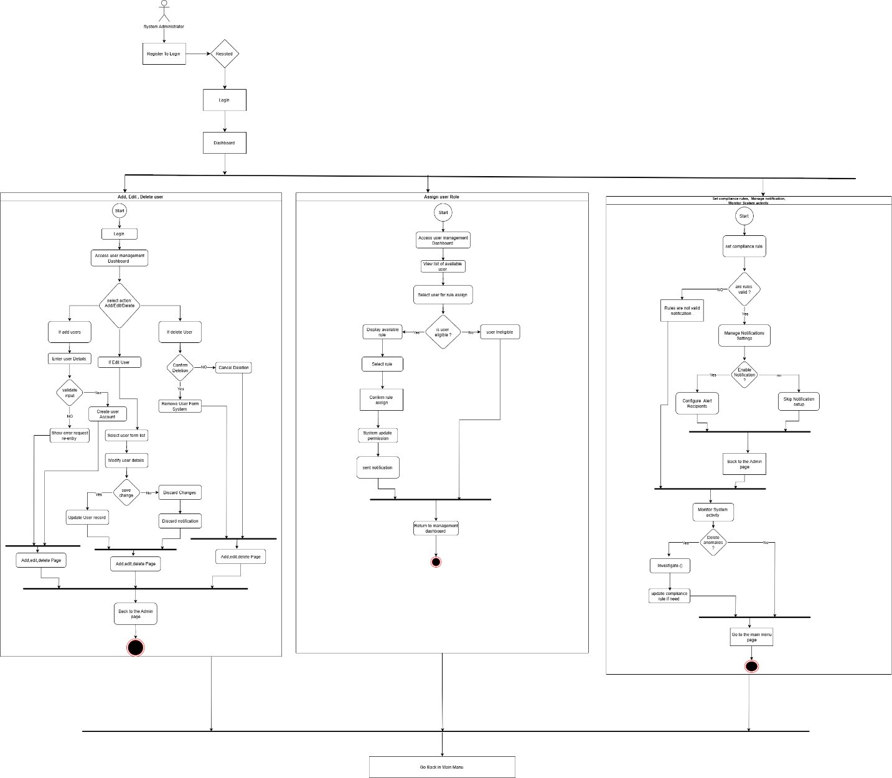
Drive link: https://drive.google.com/file/d/1gRchAAr78mkxH_J17lT5BTTXDfDnjDLm/view?usp=sharing
Compliance Manager
General User
Software developer

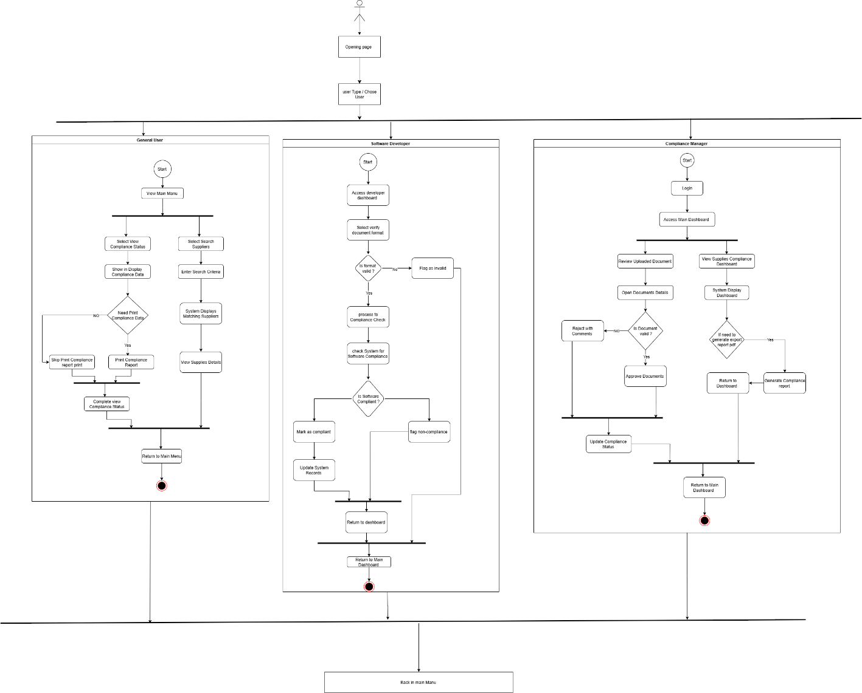
Drive link: https://drive.google.com/file/d/1JLoteTbAlqJpAojCIQvPS71NV7pUJiZU/view?usp=sharing
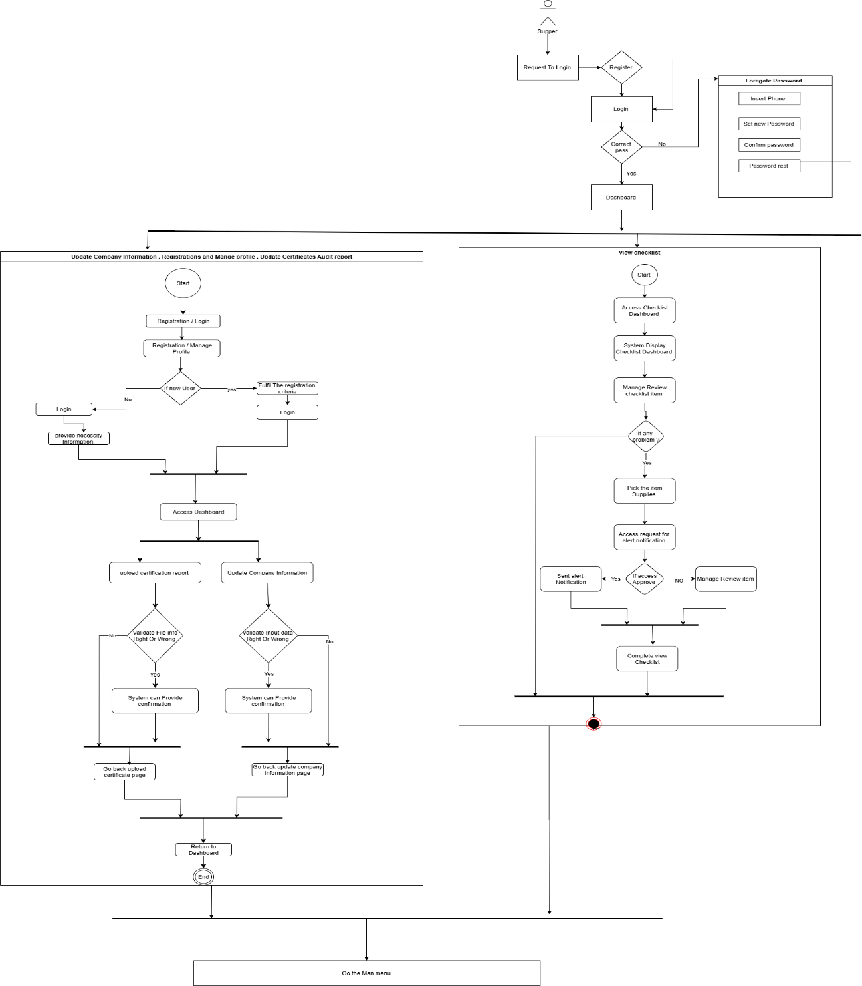
Supplier:
Drive link: https://drive.google.com/file/d/1qdD0s1qCKHJDdqaicEIXjRnhIogfYMqW/view?usp=sharing
Software Requirement Specification (SRS)
FR01 | User Registration and Authentication
Description | Users must register using institutional credentials before accessing the system. Secure login with OTP/email verification is required.
Stakeholder | Students, Faculty, Staff, Admin

FR02 | User Role Management
Description | Admins assign different roles (Student, Faculty, Staff) with varying permissions.
Stakeholder | Admin

FR03 | Security & Data Privacy
Description | The system ensures data encryption and restricted access to user information.
Stakeholder | Students, Faculty, Staff, Admin

FR04 | Lost Item Reporting
Description | Users can report lost items by providing details such as category, location, and images.
Stakeholder | Students, Faculty, Staff

FR05 | Found Item Reporting
Description | Users can report found items by submitting relevant details and images.
Stakeholder | Students, Faculty, Staff

FR06 | Lost and Found Item Matching
Description | AI automatically matches lost and found items based on descriptions and images.
Stakeholder | Students, Faculty, Staff

FR07 | Claiming a Found Item
Description | Users can submit a claim request to retrieve a found item.
Stakeholder | Students, Faculty, Staff, Admin

FR08 | Proof of Ownership Submission
Description | Users must submit proof of ownership (images, receipts, or detailed descriptions) before claiming a found item.
Stakeholder | Students, Faculty, Staff, Admin

FR09 | AI-Based Image Recognition for Matching
Description | AI scans uploaded images to detect similarities between lost and found items.
Stakeholder | System Administrator

FR10 | AI-Powered Fraud Detection
Description | AI flags suspicious or duplicate listings to prevent fraudulent claims.
Stakeholder | University Admin, System Administrator

FR11 | Smart Location-Based Alerts
Description | Users receive notifications when they are near the last known location of a lost item.
Stakeholder | Students, Faculty, Staff

FR12 | Emergency Lost Item Alert
Description | High-priority lost items (wallets, keys, IDs) receive urgent alerts for faster recovery.
Stakeholder | Students, Faculty, Staff, Admin

FR13 | Chat or Contact System
Description | Secure messaging between finders and claimants for safe communication.
Stakeholder | Students, Faculty, Staff, Admin

FR14 | Reward System for Finders
Description | Users earn points and badges for successfully returning lost items to their rightful owners.
Stakeholder | Students, Faculty, Staff, Admin

FR15 | Feedback & Review System
Description | Users can rate and provide feedback on their experience after retrieving a lost item.
Stakeholder | Students, Faculty, Staff

FR16 | Reporting Fake or Incorrect Listings
Description | Users can report false or misleading lost item listings, which will be reviewed by admins.
Stakeholder | Students, Faculty, Staff, Admin

FR17 | Admin Panel for Moderation
Description | Admins can manage users, monitor listings, review reports, and access system analytics.
Stakeholder | Admin

FR18 | QR Code for Item Verification
Description | A unique QR code is generated for found items to verify ownership claims efficiently.
Stakeholder | Students, Faculty, Staff, Admin

Use Case Diagram

- Actors For This System

  - System Administrator

  - Compliance Manager

  - Supplier / Industry Representative

  - Software Developer

  - General User

- Use Cases For The System :

  - Add/Edit/Delete Users

  - Assign User Roles

  - Set Compliance Rules & Checklists

  - Manage Notification Settings

  - Monitor System Activity

  - Review Uploaded Documents

  - Approve or Reject Compliance Files

  - Generate Compliance Reports

  - View Supplier Compliance Dashboard

  - Register and Manage Profile

  - Upload Certificates and Audit Reports

  - Update Company Information

  - View Checklist

  - Receive Expiry Notifications

  - Verify Document Formats

  - Check System for Software Compliance

  - Flag Invalid Uploads

  - View Compliance Status

  - Search Suppliers

- Use Case Diagram

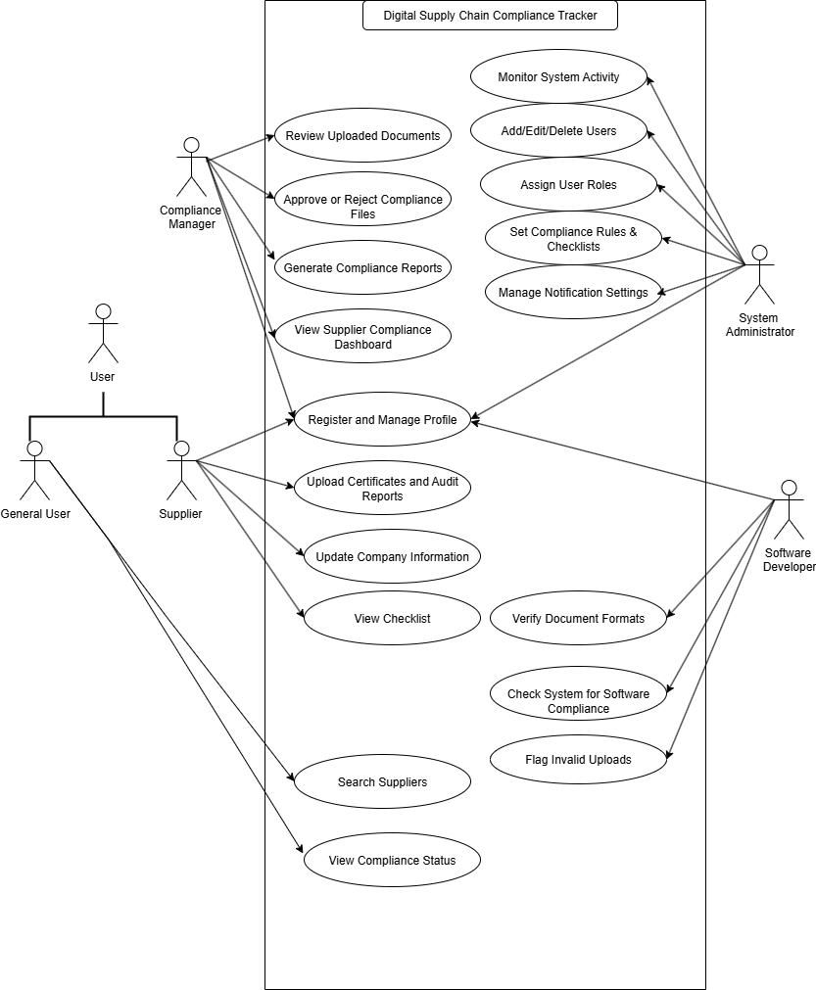
Drive link: https://drive.google.com/file/d/1oc0Ayo56-W4WAmEHNOrFfs8OrNMNOl3L/view?usp=sharing

User Case Description
Case Description-01 | Add/Edit/Delete Users
Goal | System administrators can manage user accounts efficiently.
Precondition | Administrator must be logged in with proper permissions.
Success End Condition | Notification: "User Added/Edited/Deleted Successfully"
Failed End Condition | Notification: "Operation Failed!"
Primary Actors | System Administrator
Secondary Actors | None
Trigger | Administrator initiates user management operation.
Description / Main Success Scenario | 1. Navigate to "User Management" panel.  2. Select "Add", "Edit", or "Delete" user.  3. Provide necessary user information.  4. Confirm action.  5. Notification: "User Added/Edited/Deleted Successfully"
Alternative Flows | 3.1 System Error → Retry operation.  3.2 Invalid Input → Prompt correction.
Quality Requirements | Operation must complete within 10 seconds.

Case Description-02 | Assign User Roles
Goal | Administrators can assign appropriate roles to users for access control.
Precondition | Administrator must be logged in; users must exist.
Success End Condition | Notification: "Role Assigned Successfully"
Failed End Condition | Notification: "Role Assignment Failed!"
Primary Actors | System Administrator
Secondary Actors | None
Trigger | Administrator selects a user to assign roles.
Description / Main Success Scenario | 1. Navigate to "User Roles" panel.  2. Select a user.  3. Choose role (Compliance Manager, Software Developer, etc.).  4. Confirm assignment.  5. Notification: "Role Assigned Successfully"
Alternative Flows | 3.1 User not found → Prompt to select valid user.  4.1 System Error → Retry assignment.
Quality Requirements | Role assignment must complete within 5 seconds.

Case Description-03 | Set Compliance Rules & Checklists
Goal | Compliance Manager can define rules and checklists for supplier compliance.
Precondition | Compliance Manager must be logged in.
Success End Condition | Rules/Checklists are successfully saved in the system.
Failed End Condition | Notification: "Save Failed!"
Primary Actors | Compliance Manager
Secondary Actors | System Administrator
Trigger | Compliance Manager initiates rule/checklist creation.
Description / Main Success Scenario | 1. Navigate to "Compliance Rules" panel.2. Add rules/checklists.3. Save changes.4. Notification: "Rules/Checklists Saved Successfully"
Alternative Flows | 2.1 Invalid data → Prompt correction.  3.1 System Error → Retry save.
Quality Requirements | Rule creation must complete within 15 seconds.

Case Description-04 | Manage Notification Settings
Goal | Users can manage how they receive system notifications.
Precondition | User must be logged in.
Success End Condition | Notification preferences saved successfully.
Failed End Condition | Notification: "Save Failed!"
Primary Actors | System Administrator, Compliance Manager, Supplier, General User
Secondary Actors | None
Trigger | User edits notification preferences.
Description / Main Success Scenario | 1. Navigate to "Notification Settings".  2. Select preferred notifications.  3. Save preferences.  4. Notification: "Preferences Saved Successfully"
Alternative Flows | 2.1 Invalid selection → Prompt correction.  3.1 System Error → Retry.
Quality Requirements | Preference updates must reflect immediately.

Case Description-05 | Monitor System Activity
Goal | Administrators can monitor user activities and system logs.
Precondition | Administrator must be logged in with monitoring rights.
Success End Condition | Activity reports displayed successfully.
Failed End Condition | Notification: "Failed to Load Activity"
Primary Actors | System Administrator
Secondary Actors | None
Trigger | Administrator selects "Monitor System Activity".
Description / Main Success Scenario | 1. Navigate to "System Activity" panel.  2. Select date/time range.  3. View logs and activities.
Alternative Flows | 2.1 Invalid date → Prompt correction.  3.1 System Error → Retry.
Quality Requirements | Activity data must load within 5 seconds.

Case Description-06 | Review Uploaded Documents
Goal | Compliance Manager can review supplier-uploaded documents.
Precondition | Documents must be uploaded and accessible.
Success End Condition | Document reviewed successfully.
Failed End Condition | Notification: "Review Failed!"
Primary Actors | Compliance Manager
Secondary Actors | System Administrator
Trigger | Manager selects document for review.
Description / Main Success Scenario | 1. Navigate to "Uploaded Documents".  2. Select document.  3. Review content.  4. Approve or reject.
Alternative Flows | 2.1 Document corrupted → Notify uploader.  4.1 System Error → Retry.
Quality Requirements | Review process must take less than 3 minutes per document.

Case Description-07 | Approve or Reject Compliance Files
Goal | Compliance Manager approves or rejects supplier compliance submissions.
Precondition | Documents uploaded for review.
Success End Condition | Status updated: Approved/Rejected
Failed End Condition | Notification: "Action Failed!"
Primary Actors | Compliance Manager
Secondary Actors | System Administrator
Trigger | Manager selects file for decision.
Description / Main Success Scenario | 1. Review file.  2. Choose "Approve" or "Reject".  3. Save decision.  4. Notification: "Status Updated Successfully"
Alternative Flows | 2.1 Invalid selection → Prompt correction.  3.1 System Error → Retry.
Quality Requirements | Decision must be saved within 5 seconds.

Case Description-08 | Generate Compliance Reports
Goal | System generates reports on compliance status of suppliers.
Precondition | User must have report generation rights.
Success End Condition | Report generated and displayed.
Failed End Condition | Notification: "Report Generation Failed!"
Primary Actors | Compliance Manager, System Administrator
Secondary Actors | None
Trigger | User initiates report generation.
Description / Main Success Scenario | 1. Navigate to "Reports" panel.  2. Select report type and date range.  3. Generate report.  4. Display report.
Alternative Flows | 2.1 Invalid range → Prompt correction.  3.1 System Error → Retry.
Quality Requirements | Report must generate within 10 seconds.

Case Description-09 | View Supplier Compliance Dashboard
Goal | Users can view overall compliance metrics of suppliers.
Precondition | User logged in with access rights.
Success End Condition | Dashboard loads successfully.
Failed End Condition | Notification: "Dashboard Load Failed!"
Primary Actors | Compliance Manager, Supplier, System Administrator
Secondary Actors | None
Trigger | User selects dashboard option.
Description / Main Success Scenario | 1. Navigate to "Compliance Dashboard".  2. View metrics and charts.
Alternative Flows | 2.1 Data missing → Notify user.  2.2 System Error → Retry.
Quality Requirements | Dashboard must load within 5 seconds.

Case Description-10 | Register and Manage Profile
Goal | Users can create and update personal/company profile.
Precondition | User not registered (for register) or logged in (for edit).
Success End Condition | Profile saved successfully.
Failed End Condition | Notification: "Profile Save Failed!"
Primary Actors | Supplier, General User
Secondary Actors | System Administrator
Trigger | User selects profile management.
Description / Main Success Scenario | 1. Navigate to "Profile".  2. Fill/update details.  3. Save profile.  4. Notification: "Profile Saved Successfully"
Alternative Flows | 2.1 Invalid input → Prompt correction.  3.1 System Error → Retry.
Quality Requirements | Profile update must complete within 10 seconds.

Case Description-11 | Upload Certificates and Audit Reports
Goal | Suppliers can submit compliance documents to the system.
Precondition | Supplier must have an active account and be logged in.
Success End Condition | Notification: "Document Uploaded Successfully"
Failed End Condition | Notification: "Upload Failed!"
Primary Actors | Supplier / Industry Representative
Secondary Actors | System Administrator (for verification)
Trigger | Supplier uploads a new compliance document.
Description / Main Success Scenario | 1. Navigate to "Upload Documents".  2. Select file(s) to upload.  3. Provide metadata (document type, date, description).  4. Confirm upload.  5. Notification: "Document Uploaded Successfully"
Alternative Flows | 2.1 File format invalid → Prompt user to upload valid format.  4.1 Network error → Retry upload.  3.1 Missing metadata → Prompt to fill required fields.
Quality Requirements | Document upload must complete within 2 minutes for files up to 50 MB.

Case Description-12 | Update Company Information
Goal | Suppliers can update their company details in the system.
Precondition | Supplier must be logged in.
Success End Condition | Notification: "Company Information Updated Successfully"
Failed End Condition | Notification: "Update Failed!"
Primary Actors | Supplier / Industry Representative
Secondary Actors | System Administrator
Trigger | Supplier selects "Update Company Information".
Description / Main Success Scenario | 1. Navigate to "Company Info".2. Edit required fields.3. Save changes.4. Notification: "Company Information Updated Successfully"
Alternative Flows | 2.1 Invalid input → Prompt correction.3.1 System Error → Retry.
Quality Requirements | Update must complete within 10 seconds.

Case Description-13 | View Checklist
Goal | Users can view compliance checklists assigned to them.
Precondition | User must be logged in.
Success End Condition | Checklist displayed successfully.
Failed End Condition | Notification: "Failed to Load Checklist!"
Primary Actors | Supplier, Compliance Manager, General User
Secondary Actors | None
Trigger | User selects "View Checklist".
Description / Main Success Scenario | 1. Navigate to "Checklist".2. View all assigned compliance items.
Alternative Flows | 2.1 Checklist not available → Notify user.2.2 System Error → Retry.
Quality Requirements | Checklist must load within 5 seconds.

Case Description-14 | Receive Expiry Notifications
Goal | Users receive notifications when compliance documents are about to expire.
Precondition | Notification settings must be enabled.
Success End Condition | Notification delivered successfully.
Failed End Condition | Notification not received.
Primary Actors | Supplier / Industry Representative
Secondary Actors | System Administrator
Trigger | System detects approaching expiry date.
Description / Main Success Scenario | 1. System checks document expiry dates.  2. Sends notification to user.  3. User receives alert.
Alternative Flows | 2.1 Notification delivery fails → Retry delivery.
Quality Requirements | Notification must be sent at least 7 days prior to expiry.

Case Description-15 | Verify Document Formats
Goal | System validates uploaded documents for correct format.
Precondition | Document must be uploaded.
Success End Condition | Format verified successfully.
Failed End Condition | Notification: "Invalid Document Format"
Primary Actors | System Administrator
Secondary Actors | Supplier / Industry Representative
Trigger | Document uploaded to system.
Description / Main Success Scenario | 1. System scans uploaded document.  2. Verify file type and format.  3. Accept or reject document.
Alternative Flows | 1.1 Format invalid → Notify supplier to upload correct format.
Quality Requirements | Verification must complete within 10 seconds.

Case Description-16 | Check System for Software Compliance
Goal | System verifies software compliance for installed applications.
Precondition | Software inventory must be available.
Success End Condition | Compliance verified successfully.
Failed End Condition | Notification: "Compliance Check Failed"
Primary Actors | Software Developer, System Administrator
Secondary Actors | None
Trigger | System initiates compliance check or user requests it.
Description / Main Success Scenario | 1. Navigate to "Software Compliance".  2. System scans installed software.  3. Generate compliance report.
Alternative Flows | 2.1 Scan error → Retry scan.  3.1 Missing software info → Prompt for update.
Quality Requirements | Compliance check must complete within 5 minutes.

Case Description-17 | Flag Invalid Uploads
Goal | System detects and flags invalid or suspicious document uploads.
Precondition | Document uploaded to system.
Success End Condition | Invalid upload flagged for review.
Failed End Condition | System fails to detect invalid upload.
Primary Actors | System Administrator
Secondary Actors | Supplier / Industry Representative
Trigger | Document upload completed.
Description / Main Success Scenario | 1. System scans document.  2. Detect invalid or suspicious content.  3. Flag document for review.  4. Notify relevant parties.
Alternative Flows | 2.1 Detection error → Retry scan.
Quality Requirements | Detection must complete within 30 seconds.

Case Description-18 | View Compliance Status
Goal | Users can check the compliance status of their organization or supplier.
Precondition | User must be logged in.
Success End Condition | Status displayed successfully.
Failed End Condition | Notification: "Failed to Load Status"
Primary Actors | Supplier, Compliance Manager, System Administrator
Secondary Actors | None
Trigger | User selects "View Compliance Status".
Description / Main Success Scenario | 1. Navigate to "Compliance Status".  2. System retrieves data.  3. Display status.
Alternative Flows | 2.1 Data missing → Notify user.  2.2 System Error → Retry.
Quality Requirements | Status must load within 5 seconds.

Case Description-19 | Search Suppliers
Goal | Users can search for suppliers based on compliance criteria.
Precondition | Supplier data must be available in system.
Success End Condition | Search results displayed successfully.
Failed End Condition | Notification: "Search Failed!"
Primary Actors | Compliance Manager, General User
Secondary Actors | System Administrator
Trigger | User enters search criteria and initiates search.
Description / Main Success Scenario | 1. Navigate to "Search Suppliers".  2. Enter search criteria.  3. System retrieves matching suppliers.  4. Display results.
Alternative Flows | 2.1 Invalid criteria → Prompt correction.  3.1 System Error → Retry.
Quality Requirements | Search results must appear within 5 seconds.

System Design

Data Flow Diagram
Data Flow Diagram Level 0:
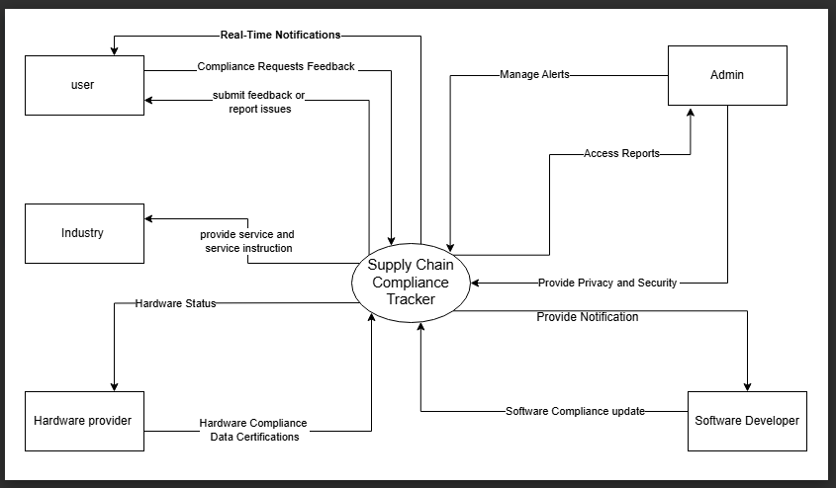

Data Flow Diagram Level 1:
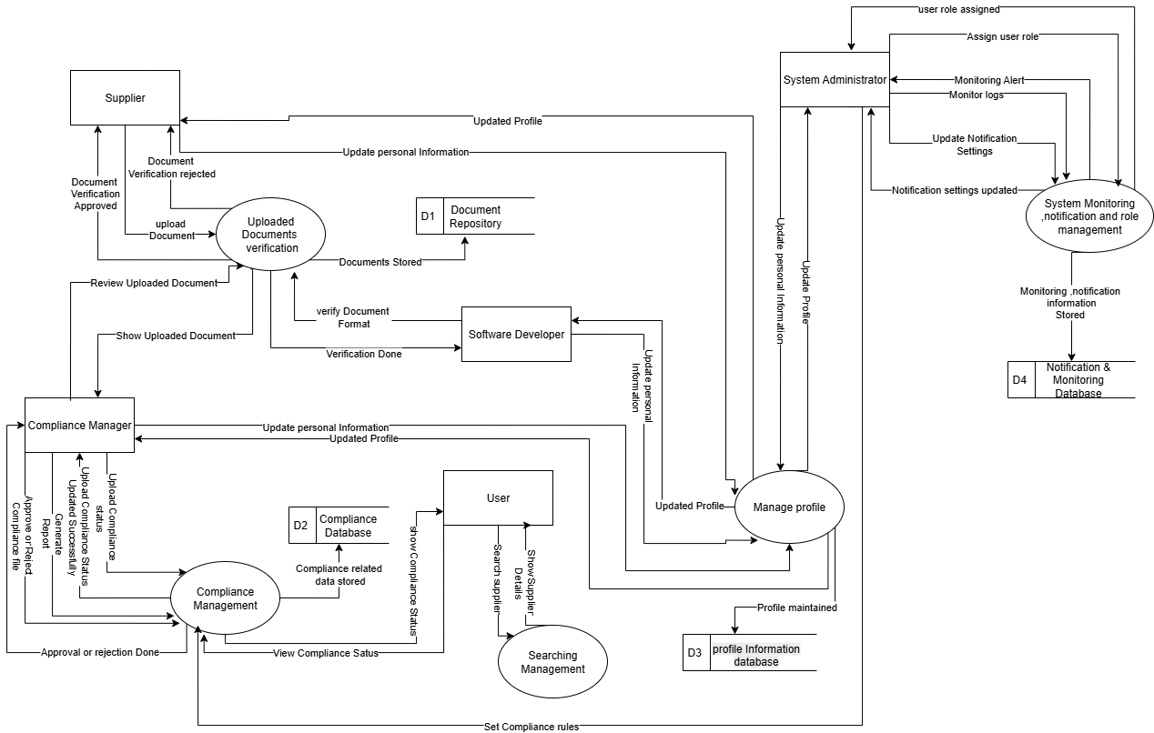

Drive Link: https://drive.google.com/file/d/1TbCvLB1aVoGmIV9AOwbL2HPEJk4gxOWv/view?usp=sharing

Data Flow Diagram Level 2:

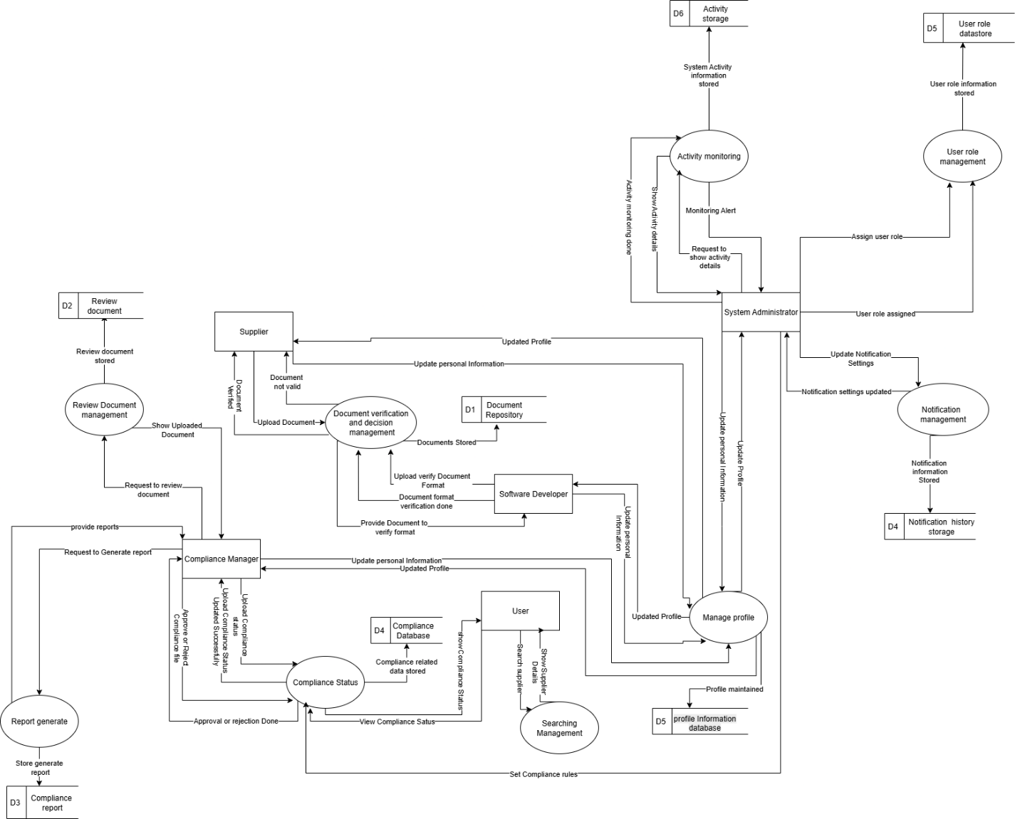

Drive link:
https://drive.google.com/file/d/1fvvFh8gF-cSZ31Mrz0dy4vVkFffK_3qp/view?usp=drive_link

1

Activity Diagram
- Update Company Information
- Registrations and Mange profile
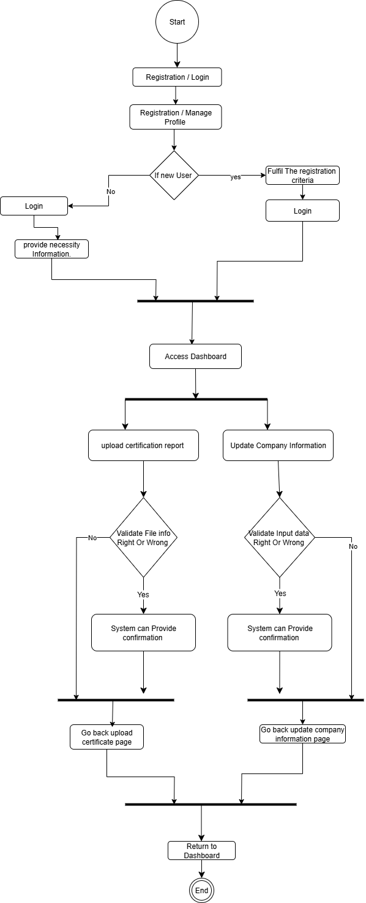
- Update Certificates Audit report
Drive link: https://drive.google.com/file/d/1y3jhV7xCmlkpkjtmVnf1AOSbBbQvmz7b/view?usp=drive_link
2.
- View Compliance Status
- Search Supplier
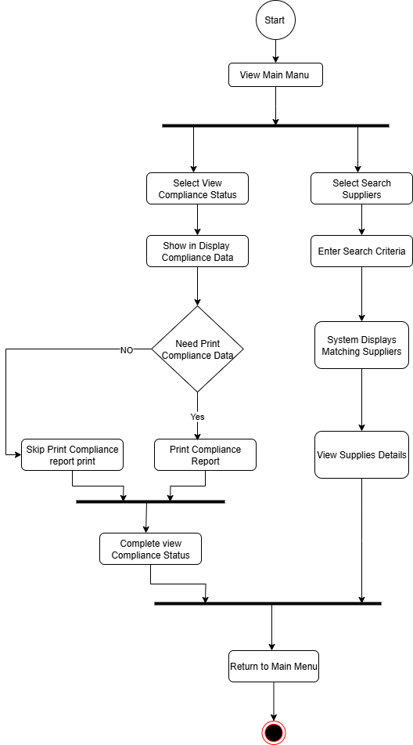
Drive link: https://drive.google.com/file/d/1EITb6_xRbiDxTjq9vQeRiW_rTGOLvvd1/view?usp=drive_link

3
- Review uploaded Documents
- Approve and Reject Compliance file
- Generate Compliance Reports
- View Supplies Compliance Dashboard
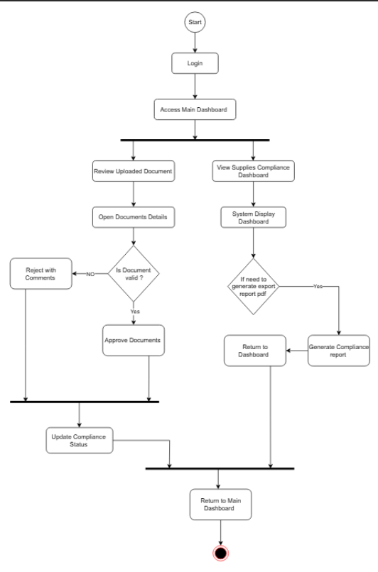

4.
- View checklist
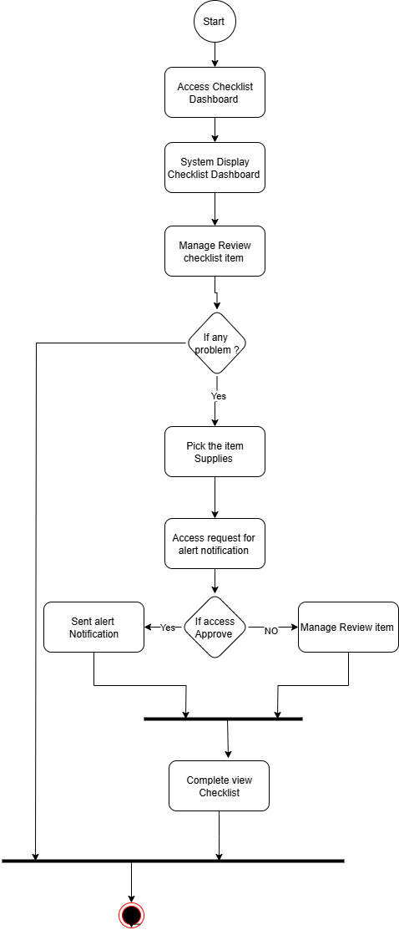
Drive link: https://drive.google.com/file/d/16j6XrhEpcnl8EwySXsi7ErAhA53Umcvm/view?usp=drive_link

5.
- Verify Documents Formats
- Check System for Software Compliance
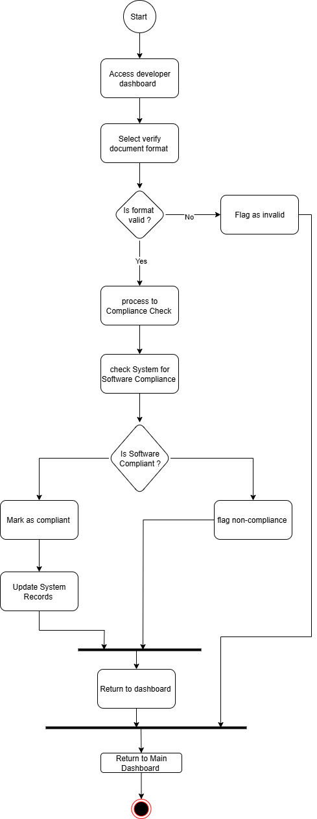
- Flag invalid upload
- Drive link: https://drive.google.com/file/d/1gLVjwZCD_Ou4R1zwbysxJoxm_iJcOica/view?usp=drive_link
6.
- Add/Edit/Delete user
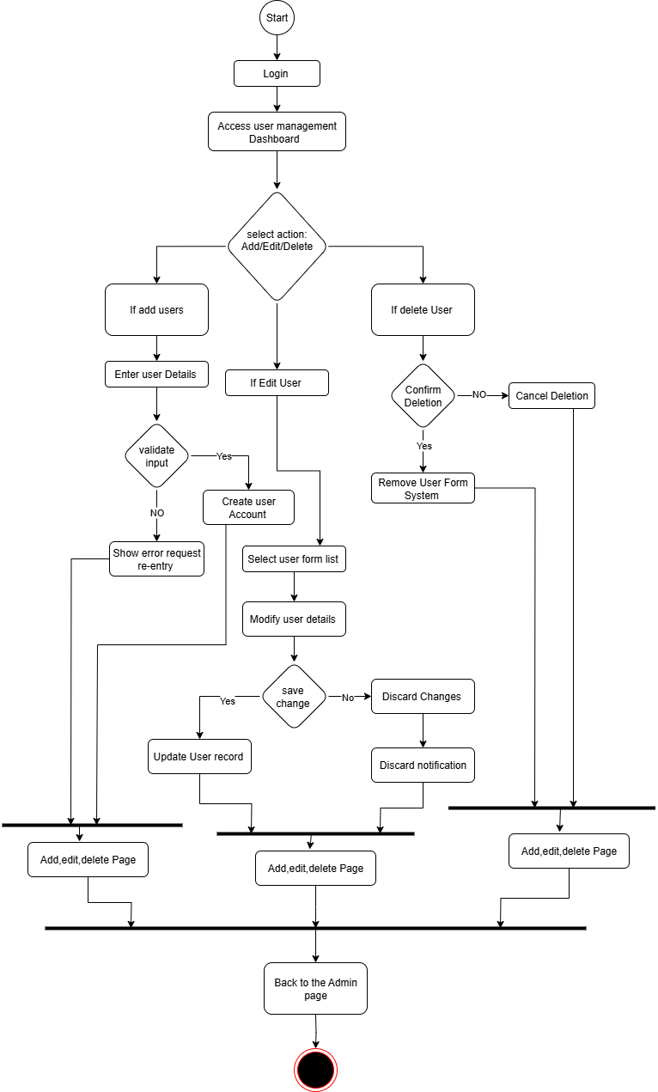
Drive link: https://drive.google.com/file/d/1I6t03GXKfZW2f_6ly1NYuEjWIPTzBU2X/view?usp=drive_link

7.
- Assign user Roles
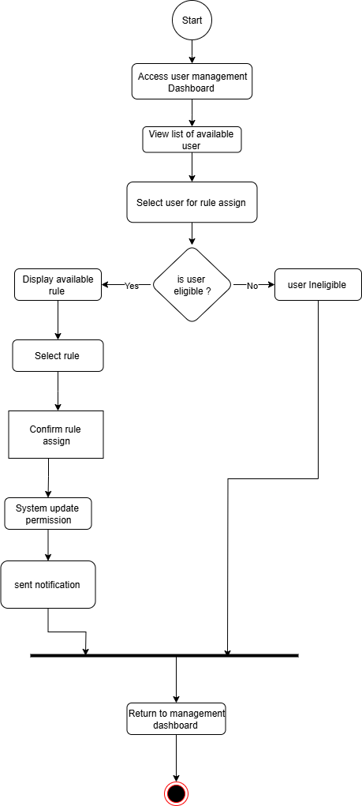

Drive link: https://drive.google.com/file/d/1GWT__lj7VJ9Yfp-gyiPxWR5I4ZY_Rfyc/view?usp=drive_link
8
- Set compliance Rules and checklist
- Manage Notification setting
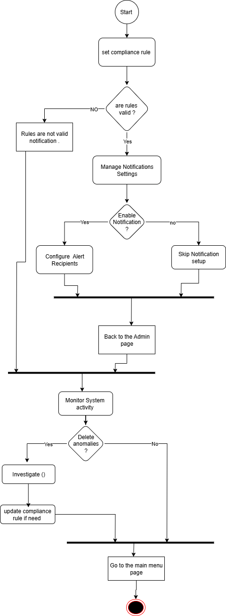
- Mentions System Activity

Drive link: https://drive.google.com/file/d/1SR6XUNIwAG1bWFc6B9mosYF2GGNBp1t3/view?usp=sharing

Sequence Diagram

1.
- Set Compliance rule and checklist
- Manage Notification Setting
- Monitor System Activity

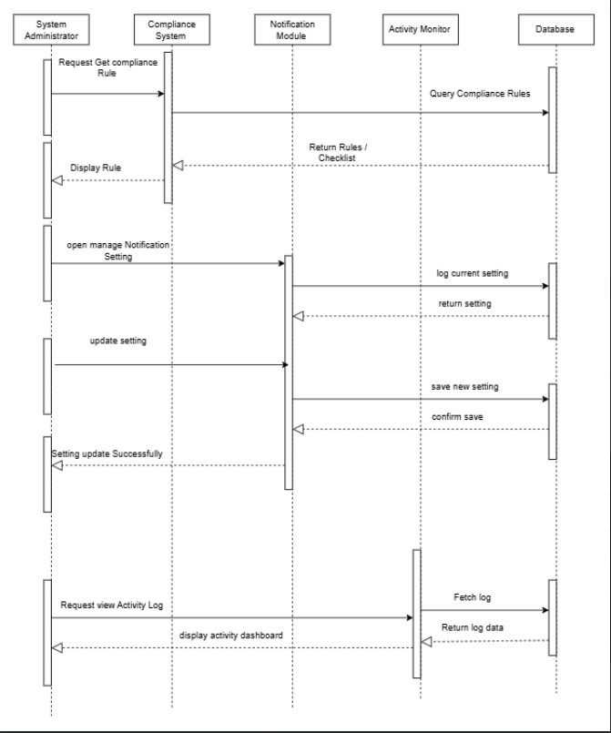

Drive Link: https://drive.google.com/file/d/1Px4nZXvxFG9bxXJffTThsCGcdyiqpzMQ/view?usp=drivesdk

2.
- Assign user Rules

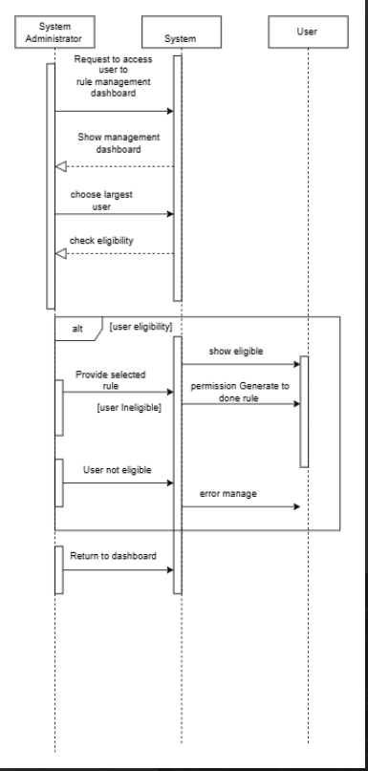
Drive link: https://drive.google.com/file/d/1Wk7xkt_wYpMLZhNbz2pwaf1IBieqvRRU/view?usp=drivesdk
3.
- Add / Edit / Delete user

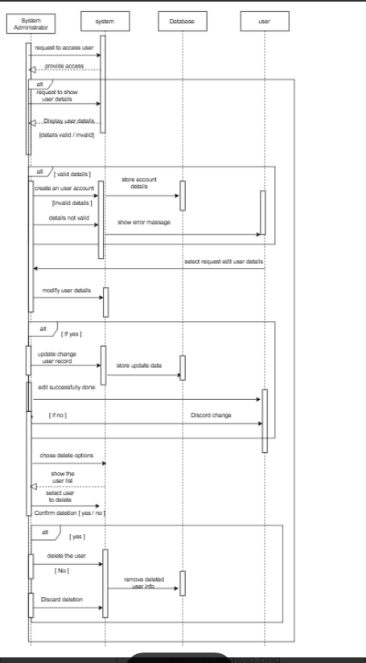
Drive Link: https://drive.google.com/file/d/1NCqy_Q7YLcjPCCfUpx7XbkNQMDjbQImM/view?usp=drivesdk

- Verify Documents Formats
- Check System for Software Compliance
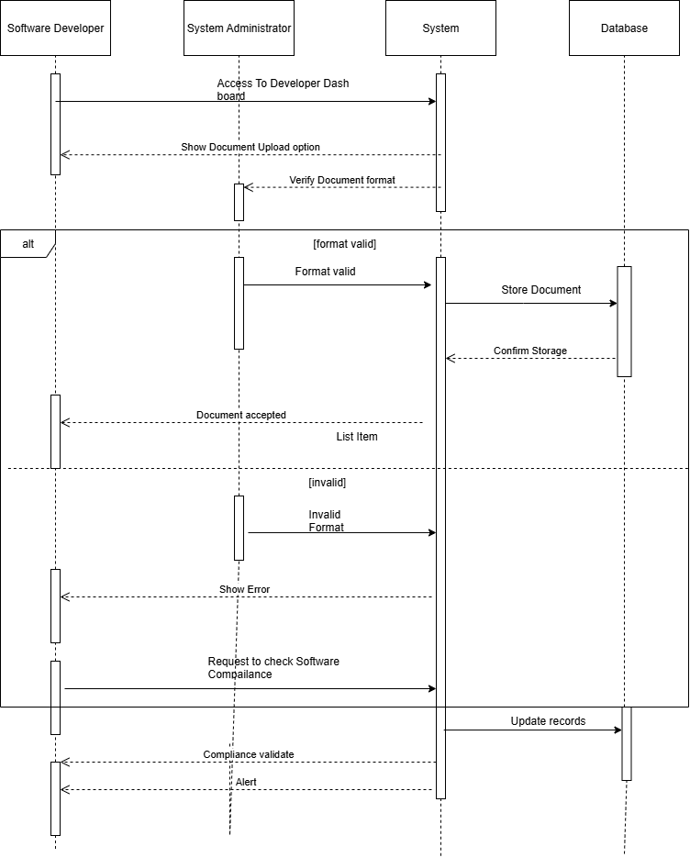
- Flag invalid upload

Drive Link: https://drive.google.com/file/d/1N9OE1-_S_PIKSnUyQJko17Ez2MkzX0vc/view?usp=drive_link

- Review uploaded Documents
- Approve and Reject Compliance file
- Generate Compliance Reports
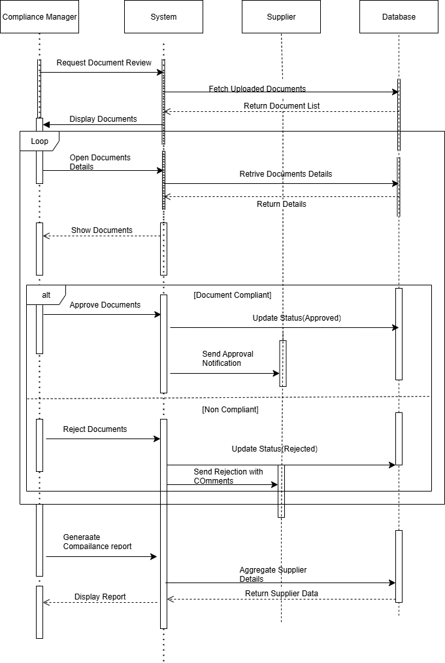
- View Supplies Compliance Dashboard

Drive Link: https://drive.google.com/file/d/19iL8RYVh2gX5c7jxIegyMDHtvUVMbxMC/view?usp=sharing

Class Diagram:
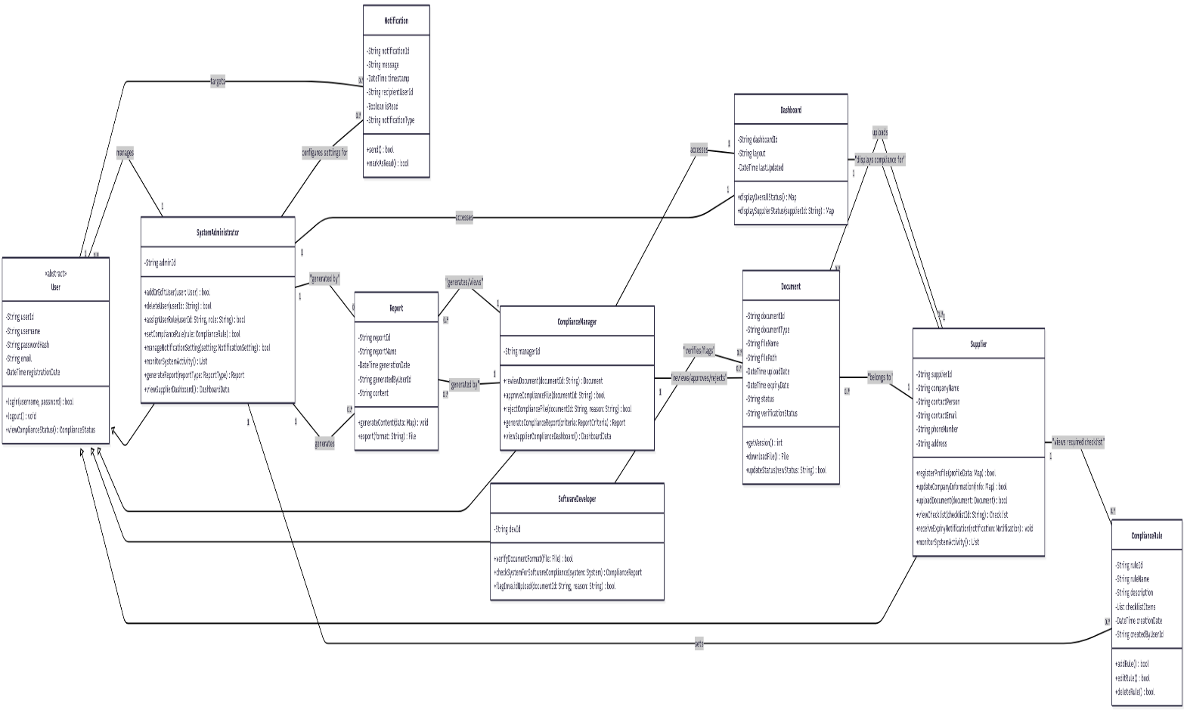

Drive Link: https://drive.google.com/file/d/1XJrGkN699gEryAG9941ICpMtuXWQOwID/view?usp=drivesdk

ER Diagram :
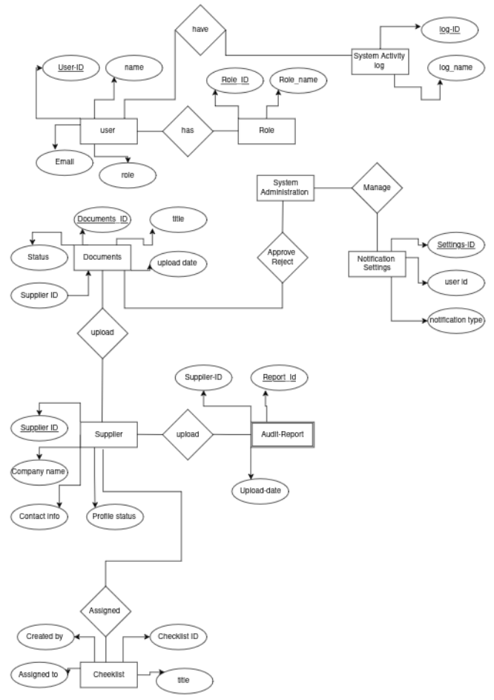

Prototype:
Figma Link
https://www.figma.com/design/52B8KW2O KEkq0W8h889Q0c/Untitled?node-id=0 1&t=5HGFsiijMK9zKxNH-1

Work Distribution:
Name or ID | Work
Md Minhazul Islam Bhuiyan  (232-35-522) | Introduction,Scope,  Activity Diagram,  DFD-0,DFD-1,DFD-2,  Block Diagram,Figma(Prototype).
Md.Nadimul Islam Nadim  (232-35-593) | Feasibility Study,  Use-case Description,  Use-case Diagram,DFD-0,  Block Diagram,ER Diagram
Sathi Begum  (232-35-503) | Stakeholder,User profile,  Sequence-Diagram,  DFD-0,DFD-1,DFD-2,  Block-Diagram,Figma(prototype)
Liza Akter  (232-35-496) | Scenario-writing,  Class Diagram,  DFD-0,Block diagram.ER Diagram.

